HAYWARD
Make
A
Difference
NEIGHBORHOOD ALERT
Mission Statement
Hayward Neighborhood Alert, in partnership with the Hayward Police Department, establishes Neighborhood Watch Groups, educating and supporting them in crime prevention and safety to improve the quality of life in the City of Hayward.
Hayward Neighborhood Alert (HNA) is a nonprofit organization, incorporated in 1978 and governed by an elected board of directors. It is a membership organization.
Members of HNA receive a periodic newsletter listing topics and guest speakers at community meetings held the last Wednesdays of January, March, May, September and October. The newsletter includes crime prevention articles by Hayward Police Department (HPD) personnel. It also includes upcoming special events.
Join Hayward
Neighborhood Alert
Become a member and join a special group of residents, like yourself, who care about their neighborhoods. Their enthusiasm and dedication make the philosophy of “Neighbors knowing and helping neighbors” a reality.
Participate in Neighborhood Watch meetings, community events, Car-A-Vans, National Night Out with block parties.
Member privileges include the HNA periodic newsletter, voting rights, and a city/police resource list and a window decal.
What is a
Neighborhood Watch?
It is the name for an individual group of residents living within close proximity of each other, headed by a Block Captain/Co Captain and recognized by HNA.
Neighborhood Watch involves neighbors getting to know each other and working together in a program of mutual assistance. Learn to recognize and report suspicious activities in your neighborhood. Learn how to fight crime, drugs and gangs by working together. Learn how to better support each other in case of an emergency. Take pride in your neighborhood and work to keep it looking attractive. Learn you can make a difference.
Neighborhood Watch is the most successful crime prevention program ever offered! By working with your neighbors and the police department, you can help fight crime in our community the most effective way—before it begins!
Working together can make a difference in Hayward. HNA and HPD are here to help make each neighborhood a better place to live.
How Do I Start a
Neighborhood Watch Group?
Any group of City of Hayward residents may organize a Neighborhood Watch group! The proposed Neighborhood Watch group should meet, appoint a Block Captain/Co Captain and determine boundary limits for the area. Create a membership roster and become members of HNA.
The newly organized Neighborhood Watch group submits their membership roster along with the name of the proposed Block Captain and street boundary limits to the HNA Board of Directors for approval.
Your first Neighborhood Watch Meetings
First Meeting – At the first meeting, the group will organize, set up the watch plan and elect a Block Captain and/or a Block Co-Captain at this meeting.
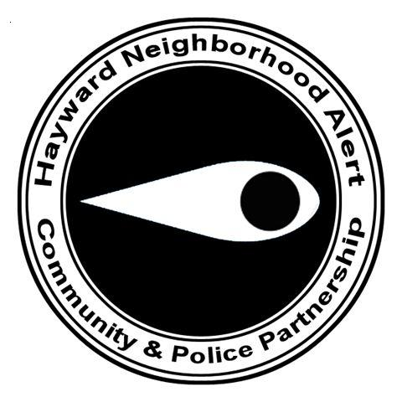
Second Meeting – At the second meeting, Police Department personnel will talk to you about specific crimes occurring in your area, when and how to use 9-1-1, and general crime prevention tips.
Third Meeting – The third meeting may consist of a presentation by Police Department personnel on home security. During this meeting, you will learn how to effectively secure your home and make it less appealing to burglars.
Continue to meet as a group. Neighborhood Watch Groups are encouraged to meet at least twice a year after the three initial sessions to discuss events occurring on your block or to review some of the many presentation materials available through the Police Department’s Crime Prevention Unit. The subjects include:
- Personal Safety
- Auto Theft Prevention
- Home Security
- Gang Awareness
- Traffic Safety
…and many more
HNA General Meetings: Neighborhood Alert members are encouraged to attend the community meetings offered through the Hayward Police Department. For meeting dates and times, call Crime Prevention at 293-5051.
Annual HNA Events

National Night Out – August
Car-A-Van and Block Parties

Red Ribbon Week – October

Holiday Party -- December

Join
Hayward
Neighborhood
Alert

DETACH HERE
Sign up now for your Hayward Neighborhood Alert Membership!
Only $12.00 per year; and receive an HNA window decal

Name Phone

Address Apts.# or Space Zip Code

E-Mail Address

Please check here if you have an interest in becoming an HNA board member. Someone from the board will contact you.

Mail this form with your check or money order to:
Hayward Neighborhood Alert – P.O. Box 6322, Hayward, CA 94540-6322

“Neighbors Knowing and Helping Neighbors”
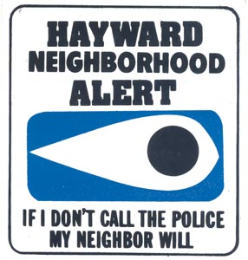

Neighborhood Watch Signs:

Neighborhood Watch Signs are available to purchase once your group has been recognized by HNA.

A new Neighborhood Alert sign is $50.
A new No Drugs Allowed sign is $45. Buy both signs for $85 and save $10. Contact HNA for a Sign Application form.

Good locations for the signs are at the entrance to your neighborhood or your street.

The signs are installed by the City of Hayward Public Works Division.
What is a Block Captain?
P.O. Box 6322
Hayward, CA 94540-6322
Voice Mail: (510) 293-7122
www.hayward-ca.gov/HNA
Block Captains are the heart of HNA. They are the leaders of their Neighborhood Watch Groups. They set up neighborhood meetings; assist in planning block parties for their neighborhoods; listen to neighborhood concerns and issues; work closely with their HNA Board Representatives and HPD; and attend community meetings or Block Captain roundtables held periodically throughout the year, keeping themselves informed and passing information along to their neighbors.
Block Captains and Block Co-Captains must be members of HNA. Once the Board of Directors has approved the proposed Block Captains, they begin a process which includes a background check and clearance through the California Department of Justice. They must attend the Community Academy, a training program conducted by the HPD, that assists residents in knowing how to work effectively with the city and the HPD. All residents of Hayward are welcome to attend this valuable training.
If you would like more information on becoming a Block Captain and/or joining HNA, call HNA Voice Mail: 510 293-7122.

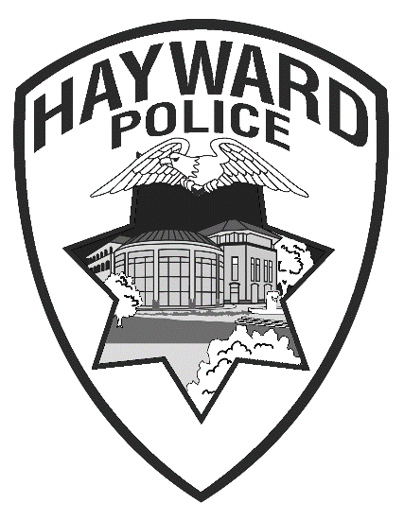

HAYWARD
NEIGHBORHOOD
ALERT

